Chapter 8, Solution 81.

t = 1/α = 0.25 leads to α = 4

But, α 1/(2RC) or, C = 1/(2αR) = 1/(2x4x200) = 625 μF

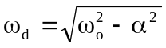

= 1/(LC)

This results in L = 1/(64π²x10⁶x625x10⁻⁶) = 2.533 μH

